### 

### Measuring The Pulse of Prosperity: An Index of Economic Freedom Analysis

**INTRODUCTION**

**1.1. Overview:** Nations with greater economic freedom have stronger economies, with a higher gross domestic product per person. Economic freedom, or economic liberty, is the ability of people of a society to take economic actions. Economic growth implies a process of increase in real national income and real per capita income. We measure the current and future economic growth by looking into the prosperity of a country considering the pillars of economic freedom such as

1) Rule of law property rights, government integrity, and judicial effectiveness.

2) Government size

3) Regulatory efficiency

4) Open markets

Economic freedom is the fundamental right of every human to control his or her own labour and property. In an economically free society, individuals are free to work, produce, consume, and invest in any way they please. In economically free societies, governments allow labour, capital, and goods to move freely, and refrain from coercion or constraint of liberty beyond the extent necessary to protect and maintain liberty itself.

**1.2 Purpose:**

We measure the pulse of the prosperity of a country by creating visualisations considering the factors such as the 2022 economic freedom score, looking into the top and bottom-ranking countries, and analysing the index score based on unemployment, financial freedom, population, 5-year GDP growth rate and inflation rate and correlating their relationships.



These include the creation of an index or metric that measures the level of economic freedom in a given country or region. This index would likely be based on a variety of factors such as the size and role of government, the level of regulation, the freedom of trade and investment, and the property rights and rule of law. The index would then be used to compare the economic freedom of different countries and regions and to identify trends and patterns over time. The final outcome of this project would be a report or publication that presents the findings of the analysis and provides recommendations for policy and economic development.

**2 Problem Definition & Design Thinking**

**2.1 Empathy Map**

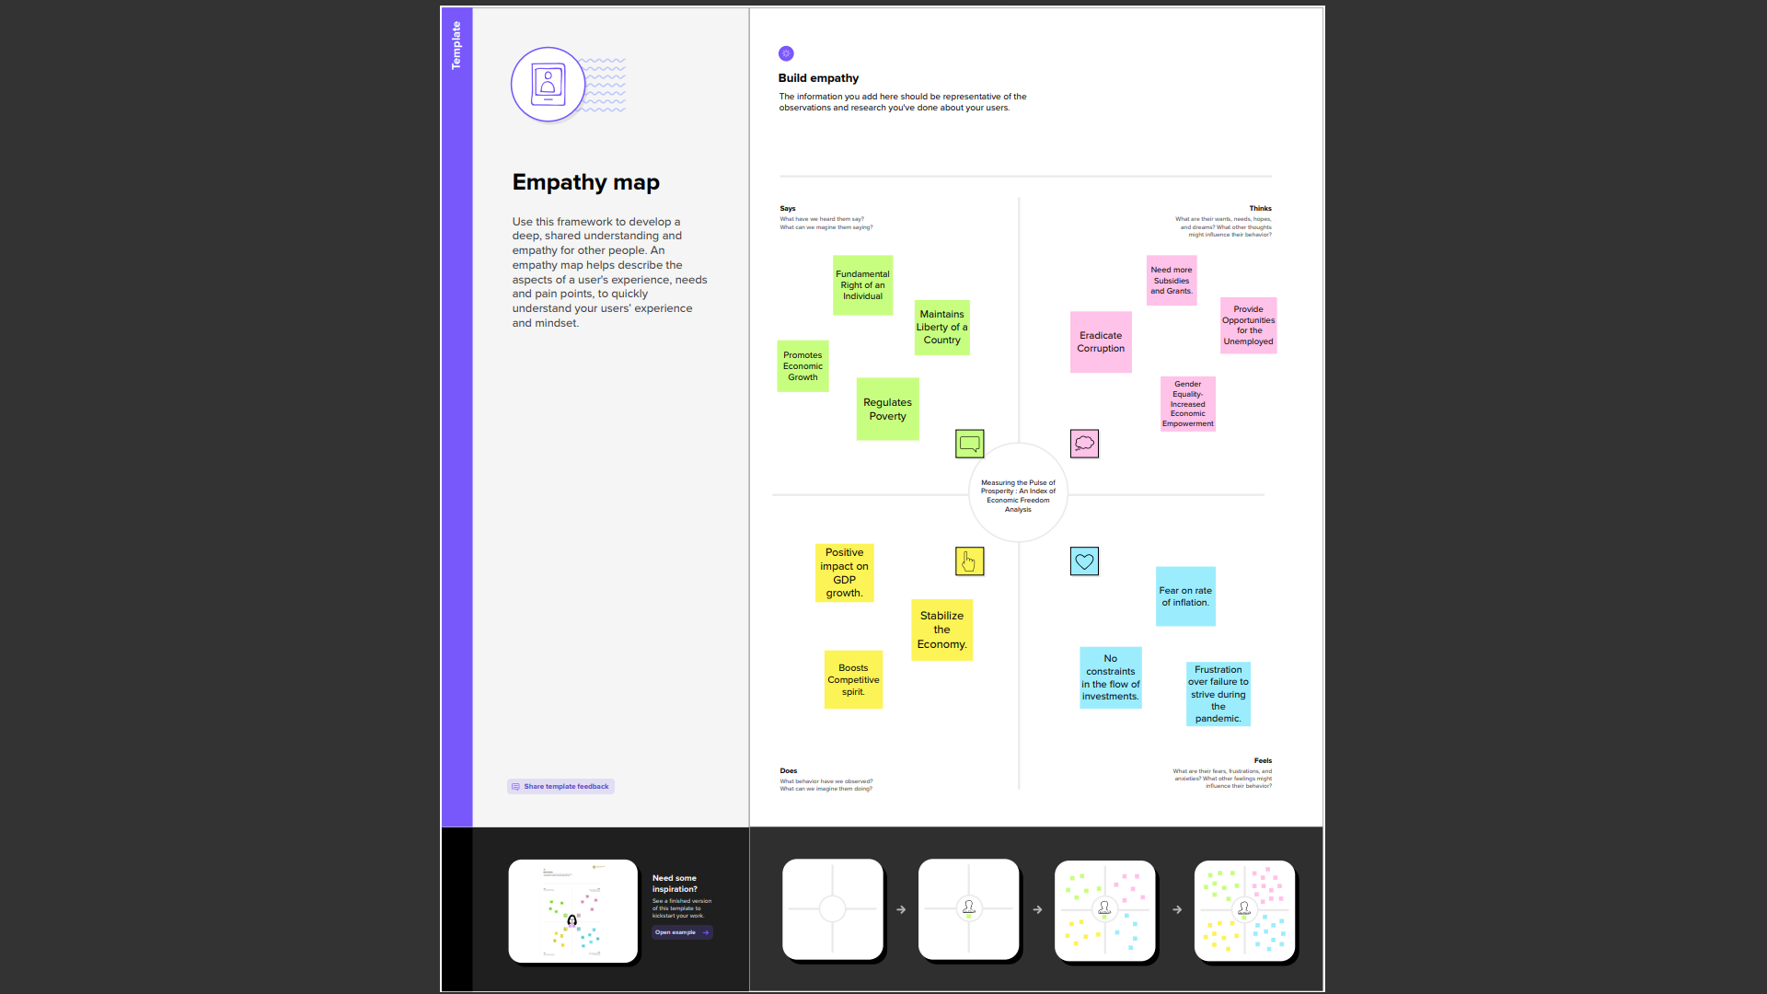



# 2.2 Ideation & Brainstorming Map

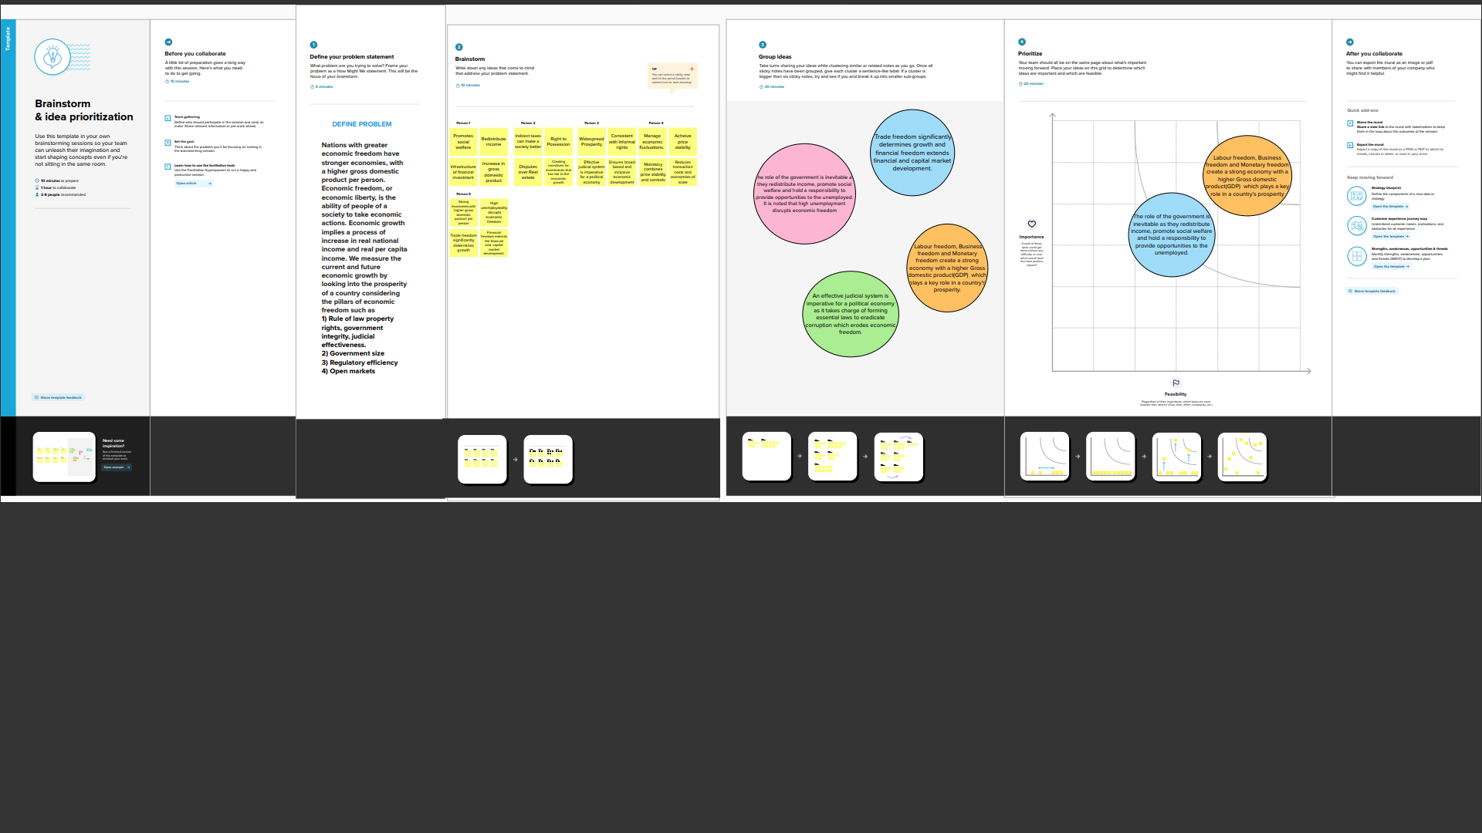



**3 RESULTS**

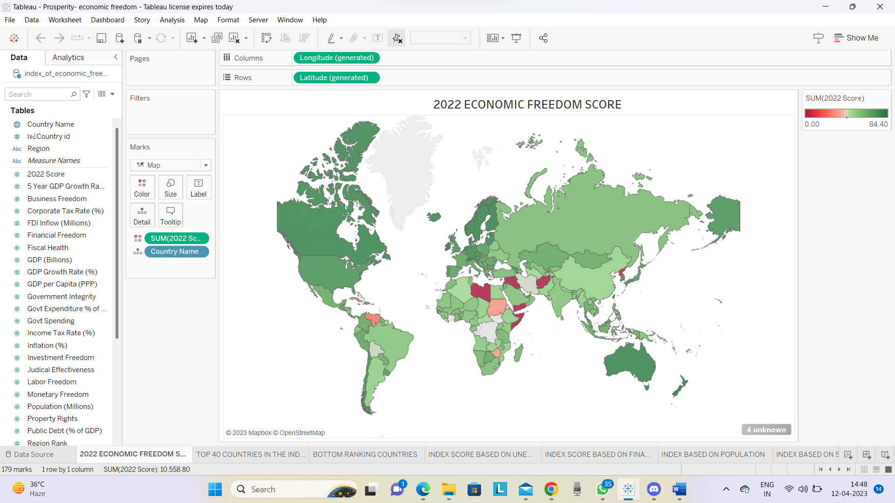

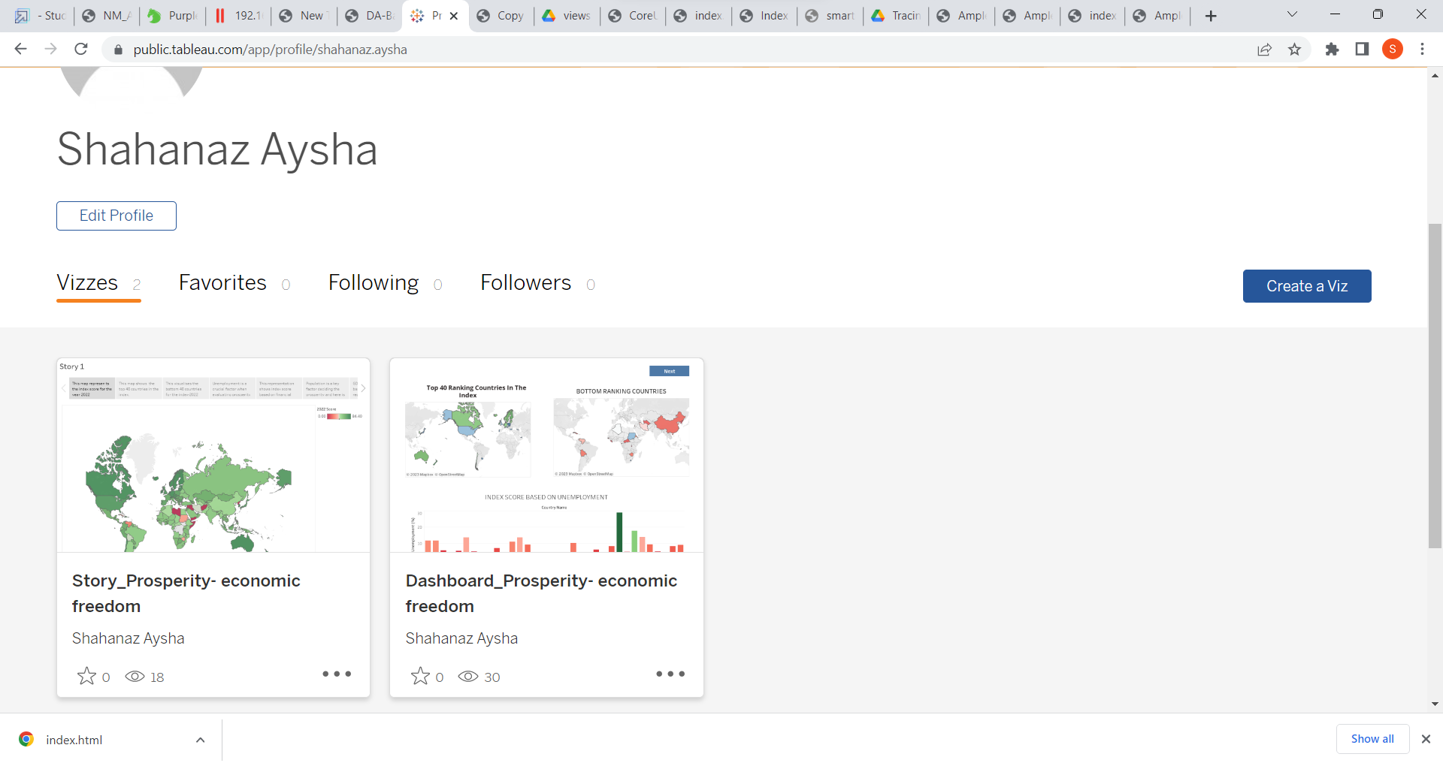



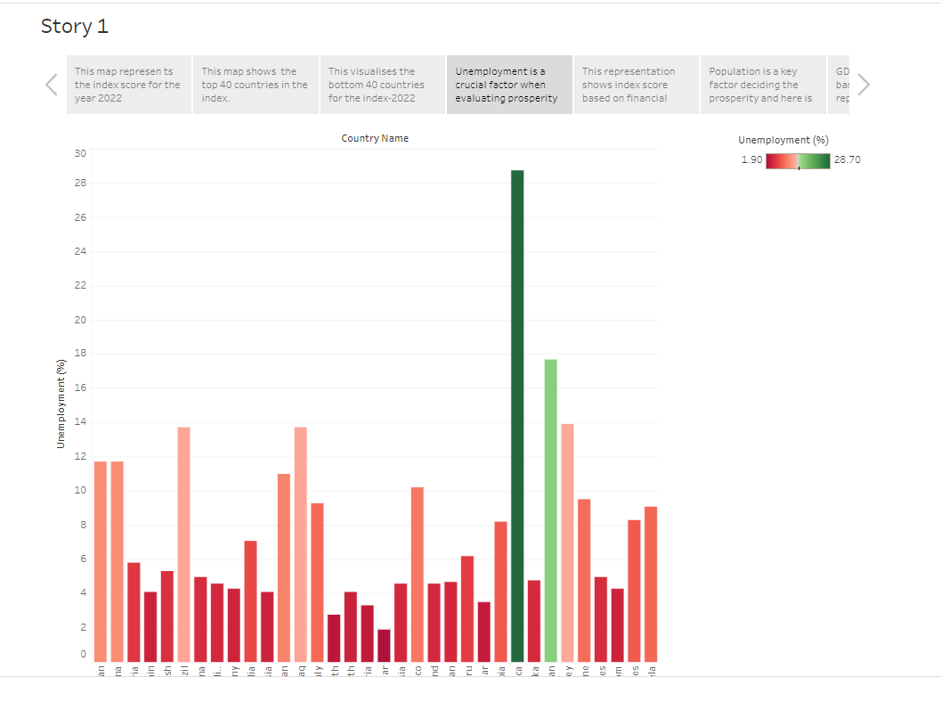



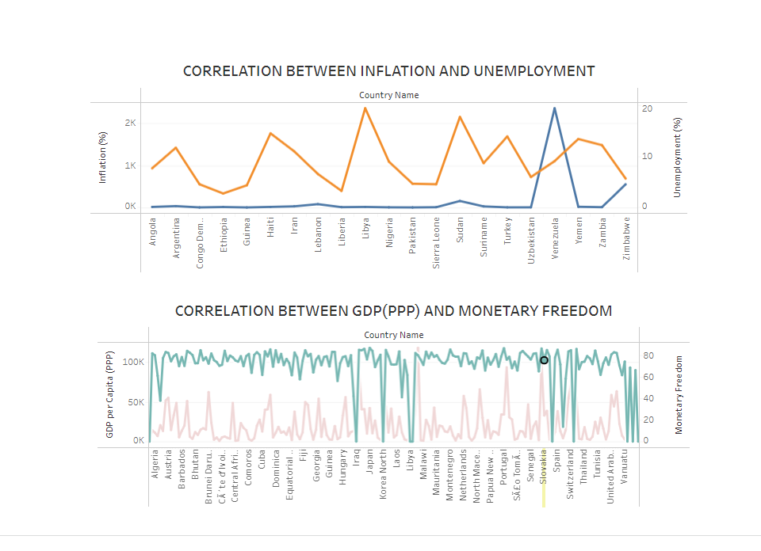

### 4 ADVANTAGES & DISADVANTAGES

### Advantages:

* This shows insights that may be missed in traditional reports.
* Gives actionable items. Actionable items can result by identifying successes and areas for improvement.
* The time saved in creating up-to-date reports means greater efficiency.
* This will undoubtedly consume a significant amount of time.
* This will undoubtedly provide a better understanding of the situation.
* Precise and deals with the investigation.
* Discovering relations between occasions.
* A superior method and better agreement.

### 

### Disadvantages:

* Incorrectly engaged persons might miss key messages.
* Provides an evaluation rather than exactness.
* Truncated graphs.
* Exaggerated scaling.
* the information that turns out to be the base of perception can be one-sided.

**5. APPLICATIONS**

* Easier to use compared to traditional reporting and it can be easily utilised in the government sector helping to determine the prosperity of a country.
* With this project developed, data is more accurate.
* It is applied more in corporate sectors and is helpful for organisations closely working to monitor the prosperity of a country.
* The factors employed here are more practical and efficient in talking about each factor when determining prosperity.

**6. CONCLUSION:**

Thus, we developed our project starting with discussions on the four important pillars of economic freedom such as

1) Rule of law property rights, government integrity, and judicial effectiveness.

2) Government size

3) Regulatory efficiency

4) Open markets

And worked on showing 11 different visualisations based on the index score, correlating their relationships, hence summarising and measuring the pulse of the prosperity of each country accurately and efficiently.



**7. FUTURE SCOPE:**

It is inevitable to neglect the government's role in affecting a country's prosperity with factors such as grants, subsidies, opportunities created for the unemployed and better facilities built in the education sector. The income from the new opportunities in the world of artificial intelligence promoting more economic freedom and the growth of the new Gig economy are some factors that need to be discussed in the near future of the project.